HOW TO REACH WALMI
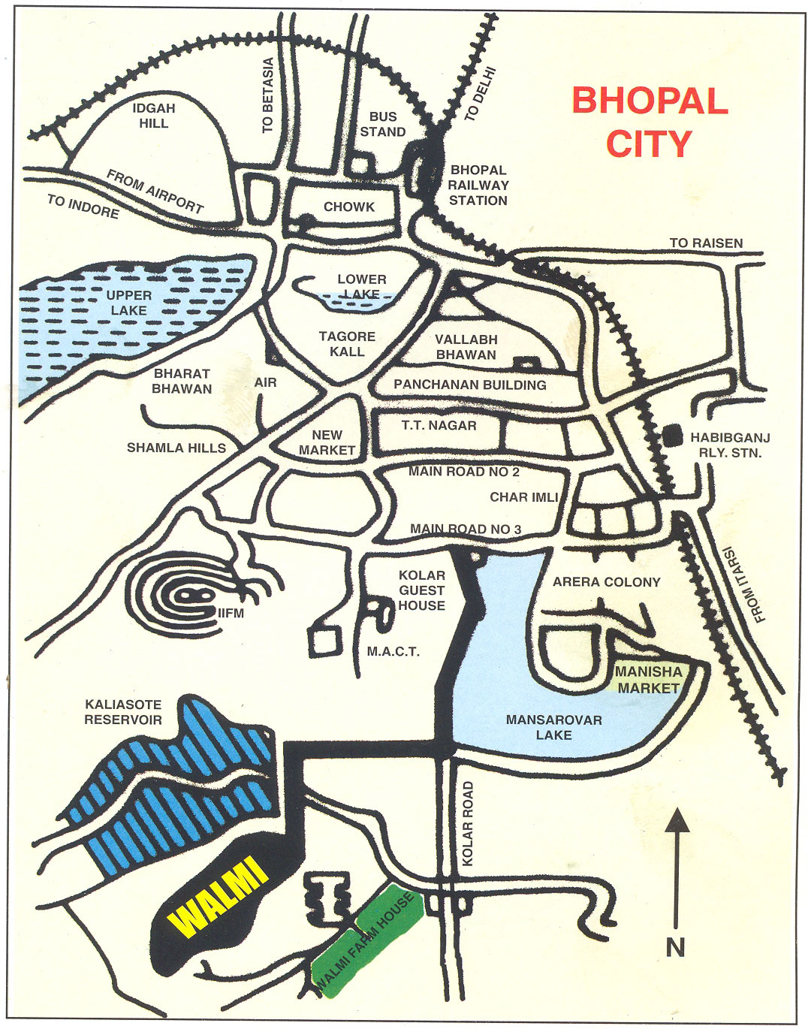
The Institute is situated at Kaliasote Dam, Kolar Road, about 5 km. from Manisha Market, Shahpura, Bhopal. Institute bus is available at 9.45 am at Manisha Market. Private Auto Rickshaw service is available at Manisha Market on payment basis.

Important Phone Numbers

Hostel : 0755 2579465
Office : 0755 2792671-74, 5291674
Fax :0755 2792432

