How to enter the details of Innovative technology of sanctioned Roads

- Go to the Proposal Mode
- Go to the sanctioned road for you have to entered the details under Innovative technology.
- Click on the + sing as given in the below screen

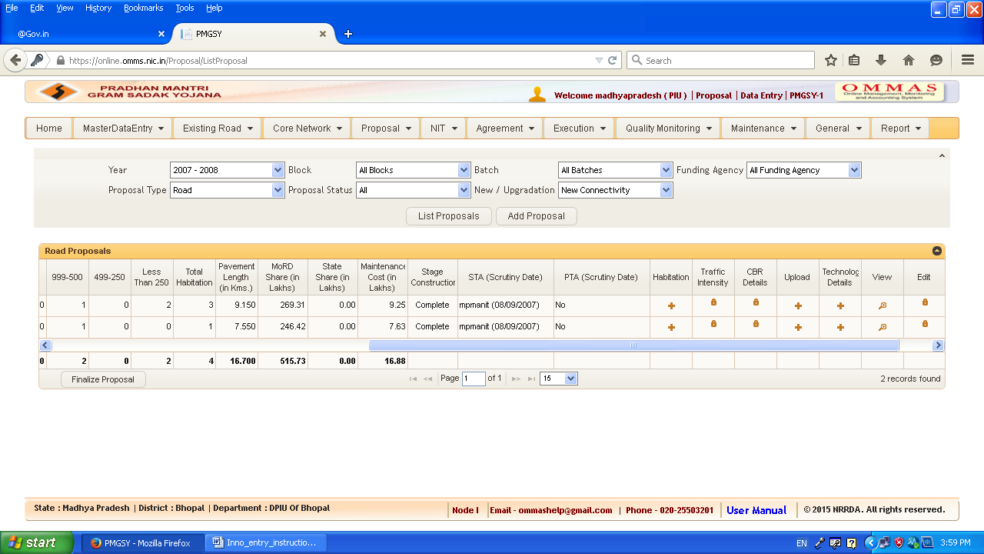

4. Entry screen will be appear
5. Enter the technology, Layer, Start Chainage, End Chainage, Total Cost of Technology, Cost of Technology for Layer as given in the below screen & save

