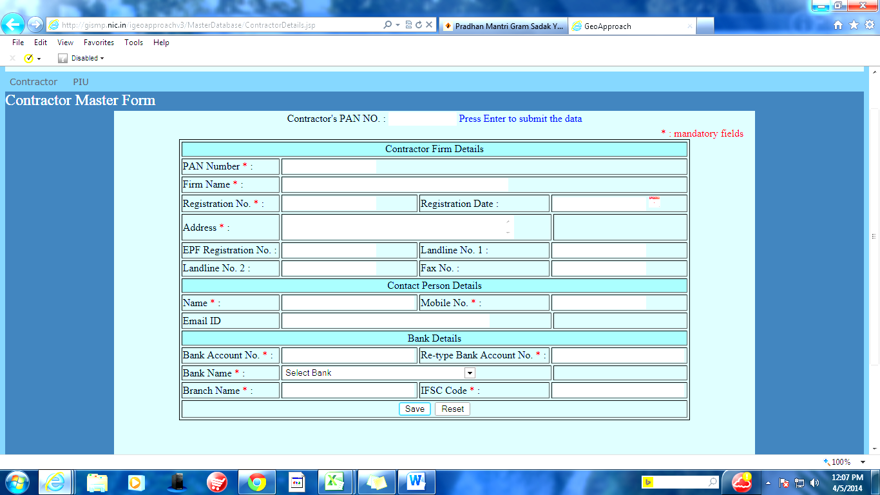
Please Tick -: New ( ) / Modify ( )

Note : -
1. * are required field
2. Fill in Capital letter
General Manager
Project implementation Unit ……….

