Annexure to ITB- Modified DPR Templates



GOVERNMENT OF MADHAY PRADESH

Department of Panchyat and Rural Development

MP RURAL ROADS DEVELOPMENT Authority

DETAIL PROJECT REPORT

FOR

Up-gradation of Rural Roads of Gravel Standards to Bituminous Surface Standards under MPRCP

Name of Work : -
Target Village : -
Village Population : -
Total Length : - km
Flexible Pavement Length : - km
Cost of Flexible Pavement :- Rs…lakh
Rigid Pavement Length : - km
Cost of Rigid Pavement :- Rs…lakh
Cost of Maintenance :- Rs…lakh
Estimated Cost (except maintenance) : - Rs…lakh
Cost per KM (except maintenance) :- Rs…lakh
Name of Block :-
Name of District :-
PIU :-

INDEX

Sl .No. Page Nos. | Particulars | Page Nos.
A. Chapters
1. | Introduction
2. | Planning and Basic Design Consideration and Adopted Geometric Design Standards
3. | Topographic Survey.
4. | Soil and Materials Survey
5. | Traffic Survey
6. | Hydrological Survey , if required
7. | Design of Junctions
8. | Improvement of existing curves of radius less than60M , if possible within available ROW/ Formation width
9. | Pavement Design
10. | Design of additional Cross Drainage , if proposed
11. | Protective Works & Drainage , if proposed
12. | Land Requirement , if any
13. | Utility shifting / relocation , if any
14. | Traffic Management and Road Safety Measures
15. | Specifications
16. | Environmental Issues
17. | Analysis of Rates
18. | Cost Estimate
19. | Construction Program
B. List of figures
Figure-1 | District Map
Figure-2 | Block Map
Figure-3 | Key Map showing project road
Figure -4 | Transect Walk
Figure – 5 | Plan & profile of the existing road showing the radius of existing curves
Figure -6 | Pavement Design Catalogues (IRC SP:72- 2015)
Figure -7 | Type design of speed Breaker as per IRC 99-1988
Figure – 8 | Type design of different category of signs , km stone & hectometer stone
C. Formats
Format 1 | Inventory of existing road in open area , Built up area & structures as per Annexure -1, 2 & 3 attached
Format 1 (A) | INVENTORY OF ROAD IN OPEN AREA
Format 1 (B) | INVENTORY OF ROAD IN BUILT UP AREA
Format 1 (C) | INVENTORY OF STRUCTURE
Format 2 | Details of proposed additional Cross drainage structures
Format 3 | Road Safety Audit Report of the existing facility as per Annexure -4 attached
Format 4 | Typical proposed cross section– Flexible Pavement
Format 5 | Typical proposed cross section– Rigid Pavement
Format 6 | Summary: Cost Estimate as per Annexure -7 attached
Format 7 | Cost estimate for Road Construction Works – Pavement Works
Format 8 | Cost estimate for additional proposed Cross Drainage Structures
Format 9 | Environmental Checklist
Format 10 | Details of profile corrective course in the existing carriageway Km wise thickness to be provided by Consultants in their own developed format
Format 11 | Check list for PIU & Third party checking – It does not pertain to the consultants
D. Annexures
Annexure– 1 | List of participants of transit walk
Annexure – 2 | Details of traffic count and projected traffic intensity (Traffic count on Annexure -6 attached)
Annexure-3 | Design of Flexible pavement as per IRC SP:72-2015
Annexure-4 | Design of Rigid pavement as per IRC SP:62-2014
Annexure-5 | Detail of additional works proposed
Annexure-6 | Format for Traffic count (3 Days)
Annexure-7 | Cost Estimate
Annexure-8 | Construction Program

1. Introduction
1.1 Government of Madhya Pradesh has set up a goal of providing all weather connectivity to all its villages by year 2018 in its Vision Document (Madhya Pradesh Drishti Patra).This also includes Black topping of all gravel roads of -------------------villages connected under CMGSY by all-weather roads in next 5 years
Objectives of the project is to upgrade the gravel roads constructed under Mukhya Mantri Gram Sadak Yojana (Chief Minister’s Rural Road Program – hereinafter called CMGSY) to the standards of Black-topped roads. This black top would mean to provide underlying layers of the required thickness and seal them with surface course basically mean bituminous topping of premix carpet, chip seal or any other standard means of surfacing prescribed by Indian Roads congress. Presently surfacing by premix carpet with seal coat is being adopted. At present the roads providing connectivity to villages having population of below 500 in normal area and 250 in tribal area are covered in the program. It is also a key ingredient in ensuring poverty reduction.
1.2 All Weather Road
An all-weather road to be taken up in this program is the one which was constructed up to gravel standard under CMGSY with necessary culverts and cross drainage structures to provide negotiable access throughout the year.
1.3 Core Network
The rural road network required for providing the ‘basic access’ to all villages/ habitations is termed as the Core Network. Basic access is defined as one all-weather road access from each village/ habitation to the nearby Market Centre or Rural Business Hub (RBH) and essential social and economic services. It comprises of Through Routes and Link Routes. Through routes are the ones which collect traffic from several link roads or a long chain of habitations and lead it to a market centre or a higher category road, i.e. the PMGSY Roads or District Roads or the State or National Highways. Link Routes are the roads connecting a single habitation or a group of habitations to Through Roads or District Roads leading to Market Centers. Link Routes may generally have dead ends terminating on habitations, while Through Routes arise from the confluence of two or more Link Routes and emerge on to a major road or to a Market Centre.

CMGSY program had also adopted this core network to take up roads of single connectivity by way of construction of gravel roads as per IRC SP 77 standards. Selected roads out of CMGSY are taken for the project.

The project road -------------------------------------------------is a link road with Route No. -----------In ----------block of -------------District. This road directly connects the habitations of ----------------with populations of ---------. Thus this link road serves the total population of -------------.

1.4 Geography
The district of -------------lies in the ----------region of Madhya Pradesh. It is situated between ---------and ----------North latitude and between -----------’ and ------------ East longitude.

1.5 Climatic Condition
The average annual rainfall of the district is ----------mm. About ----% of the annual rainfall takes place during the southwest monsoon period i.e. June to September only -----% of annual rainfall takes place during winter and about -------% of rainfall occurs during the summer months.

1.6 The Project Road
The road passes through plain or plain & rolling or hilly terrain.(Whichever is applicable). There are Primary school, Anganwadi centre, health centre / sub centre and Panchayat Building near the project road (mention appropriately) There are existing utilities like electric poles (if there, mention appropriately)along the existing road. As the project is only for up-gradation of existing gravel road, additional land will not be required.

District =
Block =
Road Name = .
Road Code =
Proposed Package No =
Road Length =
Start Point = ---------- Longitude and --------- Latitude.
End Point = ---------- Longitude and ---------- Latitude.

Sl.No. | Name of Habitation benefited | Population connected
 |  | Direct | Indirect
1 |  |  | -
Total population served |  |  | -

District, block and project road is shown in the following maps. (Fig 1, 2 & 3)

Figure -1
Figure - 2
Figure – 3

2. Planning and Basic Design Consideration and Adopted Geometric Design Standards

2.1 Alignment investigation:

The project road is recently constructed as all weather roads to gravel road standards under CMGSY after proper study / surveys of the alignment. No change in the alignment is required. The alignment was finalized during CMGSY as per the relevant IRC specifications for Rural Roads (IRC: SP-20:2002).

2.2 Design speed:

The road is designed for a ruling speed of 50 kmph, (Minimum speed of 40 kmph) being located in plain area. This is as per the provisions of IRC specifications for Rural Roads (IRC: SP-20:2002).

2.3 Right of Way (ROW)
The requirement of ROW for village roads as specified in IRC-SP 20:2002 is as below:

Road Classification | Plain and Rolling terrain
  Open area | Built up area
Rural Roads ( ODR & VR ) | 15 – 25 M 15-20 M

Against the above requirements, the present R.O.W in open area varies from 10 to 12 m, while in built up area it is 6 to 10 m. Under CMGSY program, no land acquisition is done and the required land is given by the land owners/villagers voluntarily. Keeping in view the likely very low traffic and that too light traffic on such roads, R.O.W of 10 m in open area & 6 m in built up area is considered adequate. The available ROW and formation width is enough to cater the likely traffic on the road. Most of these roads are also not through roads.

2.4 Roadway Width

Seeing the low traffic rural roads Under CMGSY are constructed with carriageway width of 3 m comprising of gravel, however in built up area the existing carriageway is only earthen. Keeping in mind that in the roads of only 3 m wide carriageway, shoulders are not only shoulders for pedestrians etc. but also work as carriageway while negotiating vehicles crossing each other as such shoulders are constructed with soil of CBR not less than 12.
2.5 Camber:
As per IRC standards, camber of 3.5% has been provided in the carriageway of the existing road. However during the passage of time, the camber is disturbed at some places, the same has been measured with the help of camber Temple at 100 m interval and the details are provided in Format 10. The deficiency shall be make good by providing required profile corrective course with crushed stone GSB.

2.6 Shoulders:
In general the available width of shoulders is 1.50 m to 2.25 m on either side in open areas and 1.5 m to 2.0 m in built up areas. Seeing the low traffic volume on the road, the width of shoulders is adequate.

2.7 Cross-drainage structures

Under CMGSY gravel road construction includes construction of all cross drainage structures.
After proper site investigation and transect walk conducted on (mention date) --------with the stake holders no additional cross drainage structure is required (if applicable) or additional cross drainage structures (mention appropriately) at the following locations are required :
Chain age in Km | Details of additional requirement with span / size
  Pipe culvert | Slab culvert | Box culvert | Causeway ( vented or Flush ) | Minor Bridge
Details of additional proposed cross drainage structures are provided in Format-2
In addition to above stake holders requested to provide sufficient number of gul (Field) culverts throughout the length of the road for irrigation purpose as after construction of the project road the stake holders are having their fields on both side of the road while the tube well for irrigation purpose is only on one side. It is therefore proposed to provide field culverts of 300 mm Ø pipes @ 200 Mt (In agriculture area) through the length to act as utility ducts as per consultation of villagers, farmers and as per requirement.
2.8 Horizontal Alignment:
As per the IRC standards, the minimum Ruling radius of 90m (Absolute minimum 60 m) is permissible in plain terrain. The details of the curves in the existing road are as below:
Sl. no. | Chainage in km | Radius of the curve | Length of the curve

From above it is clear that all the curves are not of radius less than 90 M. As such no extra provision in shape of extra widening is required.
Or
Curves are required extra widening and the same is being provided.
2.9 Vertical profile:
The existing road is in plain terrain and grade change being less than 1% no vertical curve is required and not provided.
2.10 Sight Distance:
The sight distance values for village roads as per IRC recommendations (IRC SP 20 Rural road manual) are as below:

Design Speed (km/h) | Safe Stopping Sight Distance (m)
20 | 20
30 | 30
40 | 45
50 | 60

The existing road is in plain terrain & grade change is less than 1%, safe site distance as prescribed by IRC is available all along the road.
2.11 Extra Widening of roadway on curves
As per IRC SP: 20 guidelines extra widening of roadway on curves of radius up to 60 m is provided as below:
Radius of Curve (m) | Extra Widening for 3.00 m wide single lane carriageway, (m)
Up to 20 | 0.9
21 - 60 | 0.6
Above 60 | Nil

Extra widening is being provided as per above.
2.12 Roadway width at cross drainage structures:
All along the road, roadway width equivalent to formation width of the road is provided on the cross drainage structures satisfying the standards of IRC.

2.13 Site Photographs-

Site photographs at every 200 m and other salient points are given below-
1
2
3
4
5 |  | .
6

2.14 Road Design Brief

Sl. | Location | Issue | Design Solutions
1 | Ch. 0.00 | The proposed road start from intersection at Ch. Km -----------of NH/ SH / MDR / ODR / VR | -----------------------------------------. (Proper junction is already constructed or not constructed and now proposed. In addition a culvert is required )
2 | -------- | The Gravel Road has been completed with 6.0 m formation width road and 3.0 m wide carriage way of gravel ( GSB ) having CBR greater than 30 OR crushable GSB of CBR less than 30 | ----------------------------------------------- ( Being crushable GSB , the same is being replaced by GSB of CBR more than 30% )
3 | --------(Built up area) | No crust provided / or mention what is provided | Cement concrete road is proposed in habitation area with proper drains and paved shoulders

Details of crust and other details are provided in Format-1 along with the inventory.

2.15 Transect Walk Summary

Transect walk along the project road was carried out on ----------. List of participants during transact walk is provided in Annexure-1.
Inventory of road & structures is provided at Format – 1
2.16 Road safety Audit
Safety Audit of the project road was carried out and the status is provided at Format- 3.

2.17 Checklist

Transect walk done Yes √ No
Transect walk summary table included Yes √ No
Photographs taken Yes √ No
Road safety Audit and mitigation measures included Yes √ No

2.18 The strip plan showing details of findings of transect walk are shown below in figure-4:-

Figure-4 Strip plan showing alignment details (Transact Walk)

3. Topographic Survey
Topographic survey is done to work out the quantities of profile corrective course before laying base course , quantity of earth work in raising the shoulders and correction of embankment slopes and to see the probabilities of easing the existing curves of radius less than 60 M. Plan & Profile of the project road is provided in Figure-5
4. Soil and Materials Survey

4.1 General

Testing of CBR of existing subgrade and sub base layer (GSB) with modified proctor was done following the guidelines of IRC: SP: 20-2002 and IRC: SP: 72-2007 and other relevant IS code.
Soil samples of the near by area were also tested to verify the suitability of soil for use in filling the un paved shoulders , as soil of CBR of 12% or more is to be used. Carriageway width being only 3 M, shoulders is not only shoulders but will also work as carriageway during crossing of vehicles.

4.2 Soil sample collection and Testing
Soil samples collected along the road alignment. Soil Classification tests like grain size analysis and Atterberg’s limit were conducted for all the samples collected. Modified Proctor test and the corresponding 4 day soaked CBR tests were conducted. The following tests were conducted as detailed below:
• Grain size analysis as per IS: 2720 (Part 4) – 1985
• Atterberg’s limit as per IS: 2720 (Part 5) – 1985
• Standard Proctor density test as per IS: 2720 (Part 7) – 1980
• 4 day soaked CBR test as per IS: 2720 (Part 16) – 1985 with standard proctor
4 day soaked CBR tests by standard proctor were also conducted for the sub grade soil
& Sub base GSB samples (three samples per kilometre).

4.3 Analysis of Test Results

The Road is completed up to gravel surface course whose laboratory 4 days soaked average CBR (on standard proctor) test results are summarized in table 4.1

Sl .No. | Chain age | Sub grade | Gravel ( sub base ) | Shoulder material
1

4.4 Coarse and Fine Aggregates

The stone aggregates shall be procured from nearby quarries near -----------Village at about ---- km from road site for WBM base course. The stone aggregates and screening material shall be procured from approved quarries and hot mix plant available in the area for bituminous work, concrete works, other pavement works.

4.5 Sub-soil investigation for bridges
All the CD works are already completed hence no needs for subsoil investigation.
In case some additional structures are proposed, soil investigation results are given here under.

5. Traffic Survey

5.1 General
In the present scenario of up-gradation work, 3 days, 16 hours (5am to 9pm) traffic volume count has been conducted from date -------- to ---------by at chain age km. ------of the project road. The classified volume count survey has been carried out in accordance with relevant codes (IRC: SP: 19-2001, IRC: SP: 20, IRC: SP: 72-2015).The surveys have been carried out with help of trained enumerators manually under the monitoring of Engineering Supervisor. Format for traffic survey is annexed.

5.2 Traffic Data and Analysis
The traffic count was classified into different vehicle category as given below:
- Motorized vehicle comprising of light commercial vehicle, medium commercial vehicle, heavy commercial vehicle, trucks, buses, agricultural tractors with trailers, car, jeep, two wheelers etc.
- Non- motorized vehicles comprising of cycle, rickshaw, cycle van, animal drawn vehicle etc.

Traffic volume count for this project road was done during ---------month which is lean / peak (mention whichever applicable) season for the area. The seasonal variation of two harvesting seasons of 75 days in (IRC-SP-72) each, total 150 days is considered based on local enquiry. Details of traffic survey and design parameters etc. are given in Annexure – 2.

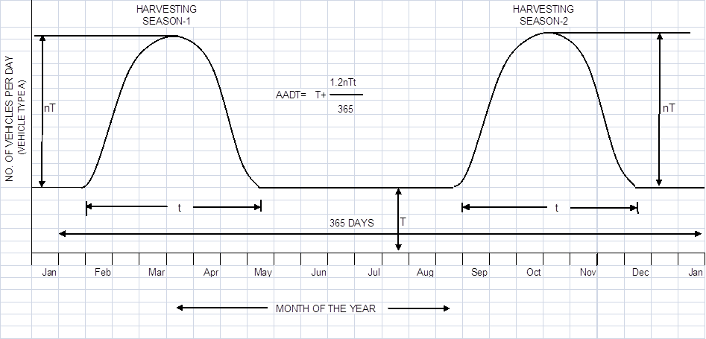

5.3 Traffic Growth Rate and forecast
For whole road length average annual traffic growth rate has taken as 6% over the design life of 10 years of project road.

6. Hydrological Survey

Hydrological Survey is not required as there is no new CD to be built on the sub project road. In case additional cross drainage structures are proposed, give the basis of calculating size etc.

7. Design of Junctions

The existing alignment of the project road intersects cross roads and forms junctions. The location of junctions and proposed treatment is given below:

Sl. no. | Location (km) | Type of intersection | Exiting condition | Proposed modification

8. Improvement of existing curves of radius less than 60M , if possible within available ROW/ Formation width :

GIVE THE DETAILS AND PROPOSAL

9. Pavement Design

9.1 General

Considering the sub grade strength , projected traffic and the design life, the pavement design for low volume CMGSY roads was carried out as per guidelines of IRC: SP: 72 – 2015, IRC SP: 77 “Design of Gravel Road” and IRC SP: 62-2014 “Cement Concrete roads". In built up area for hygienic and safety reasons, Cement concrete pavement has been proposed with a hard shoulder and appropriate line drain.

9.2 Flexible Pavement Design Approach

9.2.1 Design Life
A design life of 10 years has been considered for the purpose of pavement design of flexible and granular pavements.

9.2.2 Design Traffic
GIVE DETAILS

9.2.3 Determination of ESAL applications
Only commercial vehicles with a gross laden weight of 3 tons or more are considered. The design traffic was considered in terms of cumulative number of standard axles to be carried during the design life of the road. The numbers of commercial vehicles of different axle loads are converted to number of standard axle repetitions by a multiplier called the Vehicle Damage Factor (VDF).An indicative VDF value was considered as the traffic volume of rural road does not warrant axle load survey.
For calculating the VDF, the following categories of vehicles was considered as suggested in paragraph 3.4.4 of IRC: SP: 72 – 2015.
- Laden heavy/medium commercial vehicles
- Un-laden /partially loaded heavy/medium commercial vehicles
- Over loaded heavy/medium commercial vehicles
Towards, the computation of ESAL applications, the indicative VDF values (i.e. Standard Axles per Commercial Vehicle) are given below:-
Vehicle type | Laden | Un-laden /Partially laden
HCV | 2.86 | 0.31
MCV | 0.34 | 0.02

Assuming a uniform traffic growth rate rate of 6% over the design life (n) of 10 years, the cumulative ESAL applications (N) over the design life can be computed using the following formula (IRC SP 72, 2015, Para 3.4.4)

N = T₀ x 365 x {[(1+ 0.01r)^{n}-1] / [0.01r]} x L

Considering Lane distribution factor (L) for Single lane road = 1.0
Cumulative ESAL application (N) = T₀ x 4811 x L,
Where T₀ = ESAL application per day.
The Cumulative ESAL application for the project road as per paragraph 3.5 of IRC: SP: 72 – 2015 is presented below

Give details

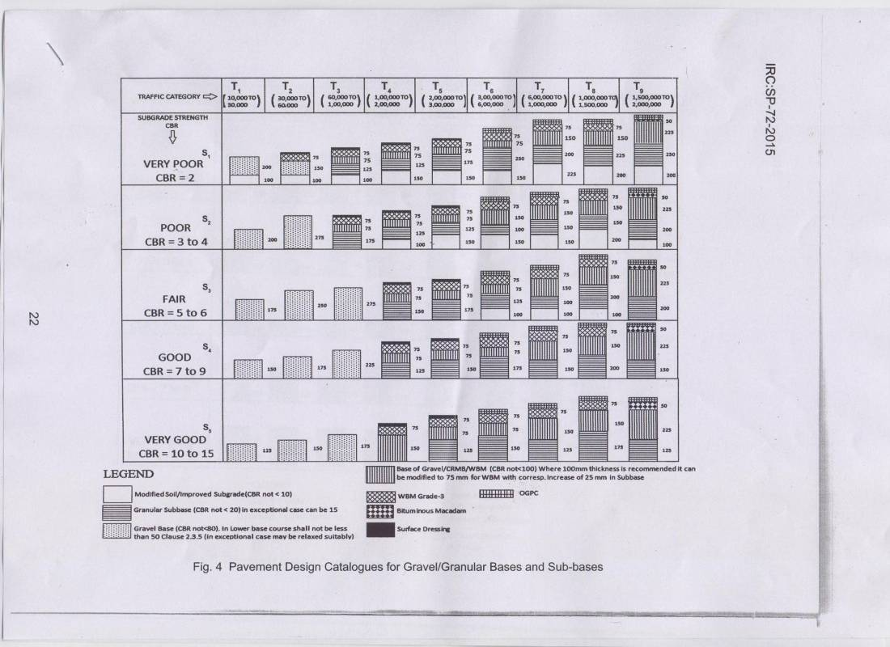
(Fig-6, IRC: SP-72-2015)

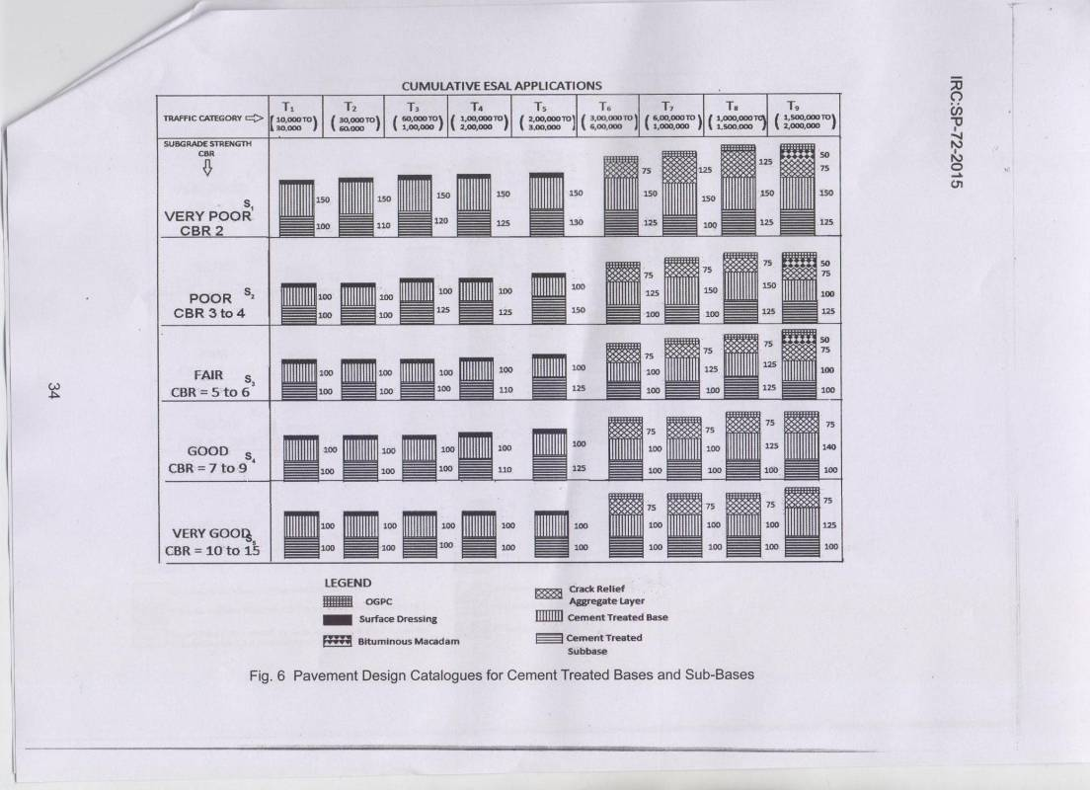
(Fig-7, IRC: SP-72-2015)

9.2.4 Sub grade CBR

The existing sub grade CBR ---% was considered and traffic falling under -------category of IRC SP 72:2015.
9.2.5 Pavement composition
The designed pavement thickness and composition will be calculated by referring Figure ------------ (Pavement design catalogue) of IRC: SP: 72 – 2015. Through at present the traffic volume is low. However, the pavement layers are provided as given below, considering the traffic on similar type of BT/sealed village road.

FROM CH ---------- TO --------- M |  | Thickness
Top Layer | Premix Carpet with Type B Seal Coat | MM
Base Layer | WBM GRADING-III | MM
Base Layer | WBM GRADING G-II | MM
Sub – Base Layer | Existing Gravel Sub - Base | MM
Sub – Base Layer | Required gravel sub - Base | MM
Total thickness :- |  | MM

9.3 Rigid Pavement

The design of rigid pavement thickness and composition has been calculated by referring table no. 4.1 and table no. 4.2 & 4.3 of IRC: SP: 62 – 2014. The temperature differential for concrete slab is 19⁰ C. .

Give design details

10. Design of Cross Drainage Works
Give details if being provided otherwise NIL

11. Protective Works & Drainage

Give details if being provided otherwise NIL

12. Land Requirement

The project road is already constructed to gravel roads standards under CMGSY and sufficient ROW is already available with MPRRDA as such there is no further requirement of land.

13. Utility shifting/relocation

13.1 Cutting of trees
Required / Not required. (Mention appropriately the no. & location)
13.2 Relocation of Electric Poles / Line / Transformer

Required / Not required. (Mention appropriately the no. & location)
  - Relocation of Hand Pumps

Required / Not required. (Mention appropriately the no. & location)
13.4 Relocation of wells

Required / Not required. (Mention appropriately the no. & location)
IF ANY ACTIVITY IS REQUIRED PLEASE GIVE DETAILS

14. Traffic Management and Road Safety Measures

The recommendations of the road safety audit have been in corporated and additional provisions as required by the audit during construction would be made accordingly. However at this stage on the basis of transact walk observations road safety measures and signs are provided as required. This is a rural road subproject of small road lengths and emphasis would be made to use locally available materials to the best possible extent like boundary stones, guard stones, km stones cement concrete signage as innovative (wherever required) etc.

14.1 Road Furniture

Road Furniture provisions of the subproject road are given as follows:
- Cautionary, mandatory and information signs
- KM stones and 200 m stones
- Delineators and object markers
- Guard post / guard stone, and speed breakers

14.1.2 Cautionary, Mandatory and Informatory Signs

Cautionary, mandatory and informatory signs are provided depending on the situation and function they perform in accordance with the IRC: 67-2001 guidelines for Road Signs.
Overhead signs are proposed in accordance with IRC: 67-2001.
14.1.3 Kilometer Stone and Hectometer Stone

The details of kilometer stones are in accordance with IRC: 8-1980 guidelines. Both ordinary and fifth kilometer stones are provided as per the schedule. Kilometer stones are located on both the side of the road.
The details of 200 m stones conform to IRC: 26-1967. 200 m stones are located on the same side of the road as the kilometer stones. The inscription on the stones shall be the numerals 2, 4,6 and 8 marked in an ascending order in the direction of increasing kilo meter age away from the starting station. Table 14.1 gives the details of Km. stone and boundary pillars provided.

14.1.4 Delineators and Object Markers

Delineators and object markers are provided in accordance with the provisions of IRC: 79-1981. They are driving aids and should not be regarded as substitutes for warning signs, road markings or barriers.
These should preferably be used made of local available materials only.

14.1.5 Guard Posts, guard stone and Speed Breakers

Guard posts are proposed on embankments of height more than 1.5 m and bridge approaches. The spacing of guard post shall be 10.0 m c/c in these areas. Typical Guard post consists of pre-cast (M 15) CC or cut stone post of size 220 mm x 220 mm and a height of 600 mm above ground level. These are to be fixed in ground at depth of 400 mm below ground level. Guard posts / Guard stone to be are painted with alternate black and white reflective paint of 150 mm wide bands. Table 14.2 gives the details of speed breakers. A layout of a typical speed breaker is given below.

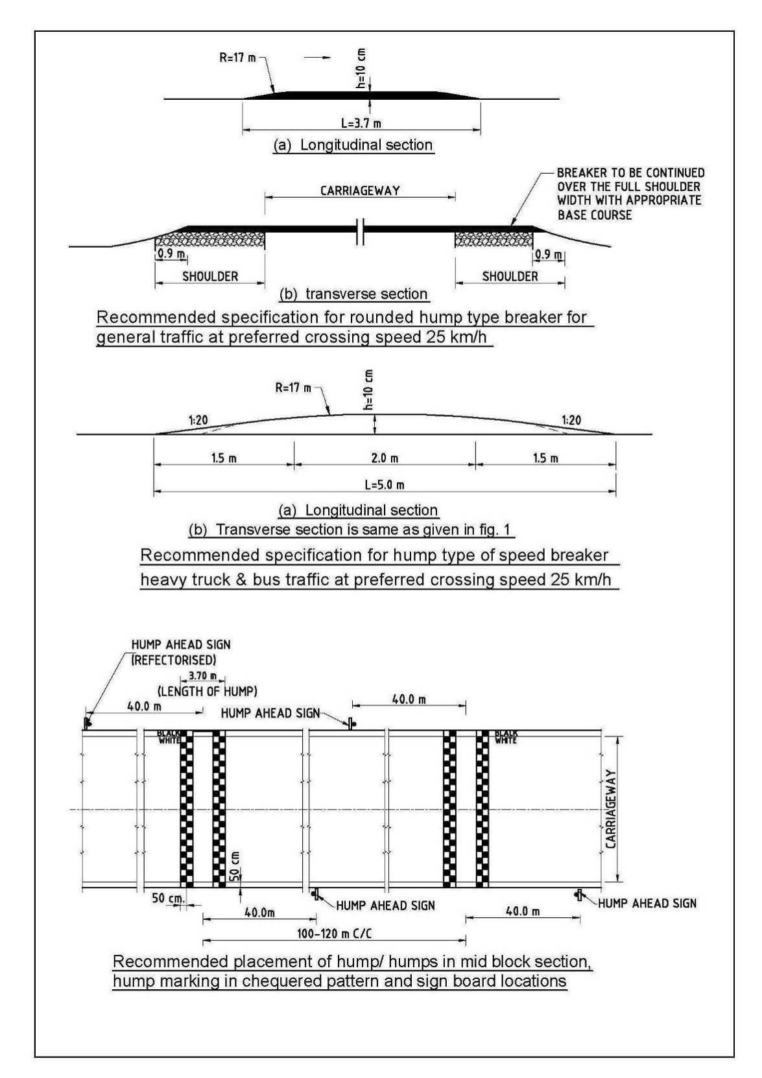
Figure 7 - Type Design of speed Breaker as per IRC: 99-1988

14.3 Checklist for Road Safety Measures

Sl | Road Safety Checklist
 | The upper layer of all shoulders of material having minimum CBR 12% compacted to a minimum thickness of 100 mm.
 | Shoulder side slopes are not be steeper than 2 H: 1 V unless stone pitching of the slope is provided.
 | Speed breakers as per requirements of IRC: 99-1988 for general traffic.
 | Speed breakers placed at the threshold of a habitation and at starting point of road.
 | Within densely populated habitations, a cement concrete (CC) pavement is constructed.
 | If a shoulder obstruction cannot be removed, hazard markers are installed to mark the Obstruction
 | Hazard markers are installed at all pipe culvert headwalls.
 | Hazard markers are installed at crossing causeways and similar CD structures.
 | Hazard markers are installed at any discontinuity in the shoulder.
 | Directional sight boards are installed on all sharp curves and bends.
 | Speed Regulatory sign boards are provided at sharp curves and bends where the curve design speed is less than 40 km/h.
 | At a main road intersection, signs and pavement markings for speed control on the CMGSY village road would be placed, side road warning signs on the main road and intersection warning signs on the village road shall be installed, and speed breakers on the CMGSY village road are provided as given in the figures (refer IRC: 99-1988).
 | Guard stones are provided on high embankment (more than 1.5 m) and at outer side of sharp horizontal curve.
 | Junction with higher category roads to be design properly and flared to provided safe mobility and clear visibility.

15. Specification
15.1 General

The “Specification for Rural Roads” published by IRC on behalf of the Ministry of Rural Development, Govt. of India has been followed along with CMGSY guidelines issued by the State of Madhya Pradesh. Other relevant codes of IRC or IS may also be used wherever necessary.
15.2 Construction Equipment

Construction by mechanical means and simple tools has been considered for the project. For handling of bulk materials like spreading of aggregates in base courses by mix-in-place method, use of motor grader & tractor-towed Rotovator has been allowed in line with the schedule of rate for road work under CMGSY. Compaction of all items shall be done by ordinary smooth wheeled roller if the thickness of the compacted layer does not exceed 150 mm. It is also considered that, hot mix plant of medium type & capacity with separate dryer arrangement for aggregate shall be used for bituminous surfacing work that can be easily shifted. A self-propelled or towed bitumen pressure sprayer shall be used for spraying the materials in narrow strips with a pressure hand sprayer. Now the tandem /vibratory rollers are also being used for rapid progress.

For structural works, looking to very small quantity of concrete, concrete shall be mixed in a locally available mechanical mixer fitted with hopper.
15.3 Construction Methods

15.3.1 Preparation of earthwork (already done in CMGSY)

. Not required.

15.3.2 Embankment work (already done in CMGSY)
Not required. Extra widening required to maintion ToP of Road way width 5.9m to 6.0m
15.3.3 Sub grade (already done in CMGSY)
Not required.

15.3.4 Sub-base

Provide details in case fresh GSB in place of crushable GSB is being provided otherwise not required
15.3.5 Base
Provide details

15.3.6 Shoulder
Earthen hard shoulder of 12 CBR shall be constructed in layers and compacted to 100% of standard Proctor’s Density. Material of hard shoulder shall be obtained from approved quarry. The shoulder layer shall be laid with base layer of pavement and simultaneously compacted.

15.3.7 Surfacing
Priming and Tack coat –
Slow setting bitumen emulsion will be applied as primer on water bound layer. Emulsion shall be sprayed on surface with pressure distributor. Rapid setting bituminous emulsion shall be used for Tack coat. This will be done as per MORD specifications Clause 502 & 503.

Surfacing –

Premixed carpet and mixed with equivalent viscosity grade bitumen shall be laid as surfacing course. 20 mm thick and Type B seal coat is considered for sealing of the premixed carpet. This will be done as per MORD specifications clause 508 & 510.

15.3.8 Rigid Pavement

Rigid pavement of M 30 cement concrete in ------mm thickness has been provided in ----m length from chain age -----to ------ over 150 mm granular sub base in built up / water logged area as per requirement. Road side drain of suitable size and shape (preferably long L type with shoulder or V type in habitation area)

15.3.9 Structural Works

Following grades of concrete are proposed for Structural Works and comply with MORD and IRC specifications:
- Cross drainage works already completed.
- 300 mm/600 mm diameter pipes proposed for approaches to habitation and for crossing irrigation pipes and utility services across the road are also proposed on the road.

16 Environmental Issues ; PLEASE ELOBORATE THE FOLLOWING

16.1 Alignment

16.2 Environmental Sensitive Area

16.3 Construction Camp

16.4 Permit / Clearance required prior to commencing of civil work

- No objection Certificate will be taken by the Contractor from SPCB (State Pollution Control Board).
- Consent to establish (CFE) and Consent to Operate (CFO) - This is required for Hot Mix Plant, WMM Plant, Batching Plant required for the subproject and the same will be taken by the Contractor from SPCB.
- Lease from Mines & Geology- This will be obtained by the Contractor for new Stone Quarry required for the project.

  - Erosion Control

  - Drainage

  - Use of Material

17. Analysis of Rates

17.1 General

Rates for various items of works of the project have been derived from the current Schedule of Rates of MPRRDA with effective from 26/05/14 for Road works and CD works. However the rates not covered under MPRRDA Schedule of Rates are worked out on the basis of MPPWD SOR / current prevailing rates / market rates. Contingency is taken as 3.0%.

17.2 Basic Rate of Material

The basic rates for stone materials, aggregates, hard shoulder material & river bed materials have been taken from local enquiry and execution of other work by department in vicinity

For bituminous materials, basic rate for equivalent viscosity grade bitumen and emulsion are taken from Indian oil corporation refinery or depot.

17.3 Lead for Materials

For stone aggregates and sand, lead from source to work site is calculated from the district map and block level map of core network and finalizing the same in discussion with PIU/PMU. The supply of different materials to worksite is by road. Lead for bituminous & steel materials are similarly obtained using SOR.

18. Cost Estimate
18.1 General
Cost Estimate of project has been arrived on the following basis
- Selection of Items of work
- Estimation of item wise quantities
- Analysis of Rates as adopted in schedule of rates of MPRRDA.

18.2 Estimation of Quantities
All the relevant road and structure work Items have been identified as per survey, design and drawings. As the project is for up-gradation of rural road, following major item of works considered are given below:
- Pavement works (WBM/WMM and Bituminous layer of 20 mm Premix carpet)
- Road safety and furniture, protection works as per requirements
- Maintenance Items for 5 Year routine maintenance.

18.3 Abstract of Cost
Unit rates are derived by using the Schedule of Rates of MPRRDA with effective from 26/5/2014 for Road Works and CD works. The abstract of Cost estimate is attached (Format 6 & Format 7).
18.4 Maintenance
Cost of Annual Maintenance for five years after completion of project have been estimated as per the Operation manual Guidelines. Required activities for the routine maintenance are given below. Out of these activities relevant to bituminous road of ordinary repairs shall be done as and when required.
- Clearing/re-shaping of road side drains.
- Pothole filling (WBM & BT).
- Filling up edges of asphalt surface.
- Dressing of berms, earth work on berms, rain cuts and dressing of earthen embankments, turffing whenever necessary.
- Re-fixing displaced guard stones, White washing / painting of guard stones, parapets of wheel guards CD works.
- Fixing disturbed caution board / Village Name board / Speed limit board, etc.
- White washing and painting of trunks of trees.
- Cutting of branches of trees etc. obstructing flow of traffic and line of sight, and cleaning wild growth on berms.
- Maintenance of catch water drains.
- Clearance and de silting of cross drains.
- Filling up local depressions, ruts, potholes and erosion control (for BT Road)
- Painting of Kilometre & Hectometre stones, Logo & Sign Board
- Painting of road markings
Total Cost of 5 year Routine Maintenance Works for subproject road is attached in Format 7.
19. Construction Program
19.1 General
It is very likely that the Construction of the Trench -1 roads will start from -----------. However, the construction program is based for a total working period of 12 months, including raining season considering the program set out by the State. Generally, dry working season of about 8 months are required for construction of CMGSY roads.
19.2 Realistic duration
Details of construction program are shown in the Annexure -5

FORMAT-1 (A) ---- Cont.
INVENTORY OF ROAD IN OPEN AREA
Chain age from --- to --- | Available ROW in Mts. | Available Formation width in Mts. | Average height of Embankment in MT's | Available width of Carriageway in MT's | Average thickness of Gravel Layer in MM | Status of Camber of Carriageway( O.K. or require Profile correction ) | Width of Earthen Shzoulders in MT's ( LHS & RHS ) | Edge drop of Earthen Shoulders in MM | Status of slope of Embankment ( O.K. or require correction ) | Distance of School Building , if any , from center line of road | Distance of Anganwadi Center , if any , from center line of road | Distance of Panchayat Bhawan , if any , from center line of road | Distance of Health Center / Sub Center Building , if any , from center line of road | Is any Electric Pole with in Formation Width , if yes , give offset from center line of road | Is any tree ( Girth of 60 Cm or more ) with in Formation Width , if yes , give offset from center line of road | Is any Hand Pump with in Formation Width , if yes , give offset from center line of road | Is any House / Other Structure of a private person with in Formation Width , if yes , give offset , length & name of owner from center line of road

FORMAT 1 (B)
INVENTORY OF ROAD IN BUILT UP AREA
Chain age from – to --- | Availbale ROW in MTs | Available Formation Width in MTs | Width of Carriage way in MtS | Existing Pavement type ( Gravel / Concrete / Brick Soling ) if any | Thickness of existing pavement , if any in MM | Status of Shoulders ( Paved or Earthen ) | Width of Shoulders ( LHS / RHS ) in MTs | Status of side Drains ( exist or not ) IF EXIST THEN type of Drains and Length in MTs ( LHS / RHS ) | Chain age from – to --- | Availbale ROW in MTs | Available Formation Width in MTs | Width of Carriage way in MtS | Existing Pavement type ( Gravel / Concrete / Brick Soling ) if any | Thickness of existing pavement , if any in MM | Status of Shoulders ( Paved or Earthen ) | Width of Shoulders ( LHS / RHS ) in MTs | Status of side Drains ( exist or not ) IF EXIST THEN type of Drains and Length in MTs ( LHS / RHS )
FORMAT – 1 (C)
INVENTORY OF STRUCTURE
Chain age in Km | Pipe Culvert with Dia & no of Rows | Slab Culvert with Span in Mt | Box Culvert with cell size in Mt | Vented Causeway with pipe dia and no. of Rows | Flush Causeway | Minor Bridge with Span Arrangement in MTs | Status of Retaining wall if any ( type ie CC / Brick ) and height in MTs. | Chain age in Km | Pipe Culvert with Dia & no of Rows

ROADS PROPOSED IN CMGSY FOR RURAL CONNECTIVITY(PAVEMENT LAYERS)
ROADS PROPOSED IN CMGSY FOR RURAL CONNECTIVITY (CROSS DRAINAGE STRUCTURE) |  |  |  |  |  |  |  |  |  |  |  |  | FORMAT : 2
DISTRICT: | ………………………………
S. No | Name of block | Name of Road | Existing or proposed | Road length (Km) | EXISTING CD STRUCTURE BY TYPE |  |  |  |  |  | DETAIL PROPOSED CD STRUCTURE BY TYPE |  |  |  |  | TOTAL COST OF PROPOSED CD STRUCTURE | TOTAL COST OF PAVEMENT (In lAKH) | TOTAL COST OF THE ROAD
 |  |  |  |  | HUME PIPE CULVERT |  | BOX/ARCH CULVERT |  | MINOR BRIDGE/CAUSE WAYS |  | HUME PIPE | VENTED Cause way | Slab Culvert | FCW | Box Culvert
 |  |  |  |  | No. | DIA (MM) | No. | Length | No. | Length
1 | 2 | 3 | 4 | 5 | 6 | 7 | 8 | 9 | 10 | 11 | 12 | 13 | 14 | 15 | 16 | 17 | 18 | 19
 |  | Existing
 |  | Proposed

FORMAT - 3
Road Safety Audit Report of the existing facility

- BUILDING OBSTRUCTING SITE DISTANCE ( GIVE DETAILS WITH DISTANCE FROM CENTER LINE OF ROAD ) :
- ANY OTHER OBJECT ( TREE / POLE / ETC ) OBSTRUCTING SITE DISTANCE ( GIVE DETAILS WITH DISTANCE FROM CENTER LINE OF ROAD ) :
- DETAILS OF SHARP CURVES , IF ANY , REQUIRING SPEED SLOW DOWN MEASURES :
- DETAILS OF JUNCTIONS REQUIRING DEVELOPMENT OF JUNCTION ( FLARING OF INNER & OUTER EDGES ) & SIGNS :
FORMAT - 4
Typical proposed cross section– Flexible Pavement
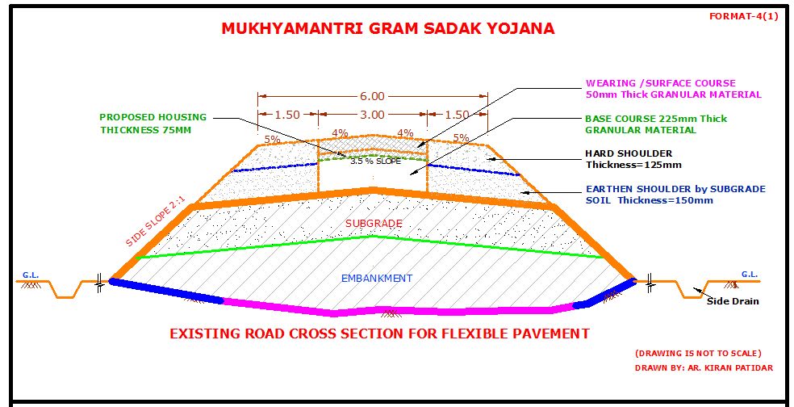
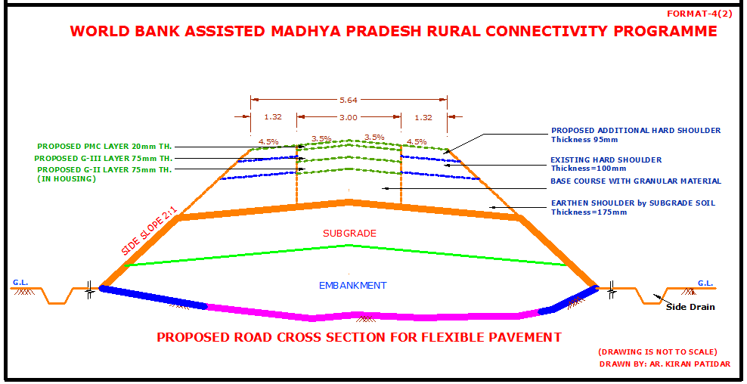

FORMAT - 5
Typical proposed cross section– Rigid Pavement

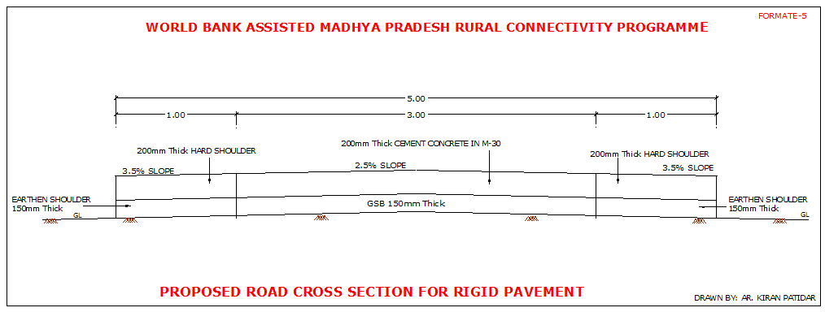

FORMAT – 6 Abstract of cost
Abstract of cost be worked out as below
a. Cost of Pavement as per Annexure :
b. Add @ 3% for Extra Widening
On curves and Junctions of village
Roads taking off from the road :
Total cost of Pavement :
c. Cost of structures :
d. Total Cost of Works :
e. Cost of ESMF :
Add Physical contingency @ 3 % of Cost ( e ) :
Add Extra @ 1% for tier one quality control of Cost ( e ) :
Add Extra @1% for Labor Cess of Cost (e ) :
Grand Total Cost :
Cost for five years Maintenance :

FORMAT – 7

Cost estimate for Road Construction Works – Pavement Works

DETAILED COST ESTIMATE FOR ROAD CONSTRUCTION
Road Name :- |  |  | BLOCK :- |  |  |  |  | Package No | MP-
Length of Road (M) :- |  |  |  |  |  |  |  | DISTRICT :-
S.No. | SOR No | DESCRIPTION OF ITEMS | Nos | L(m) | B(m) | D(m) | UNIT | QUANTITY | RATE (Rs.) | AMOUNT (Rs.) | REMARKS

FORMAT-8

Cost estimate for additional proposed Cross Drainage Structures

Road Name:
S.No/ SOR No | Description | No. | Length | Breadth | Depth | Quantity | Rate | Unit | Amount

Format-9
RURAL ROADS: ENVIRONMETNAL CHECKLIST
Road Name.-
Block Name:-
District Name:-
Total length of the road:-
A.) Climatic Conditions
Temperature |  | High - |  | Low -
Humidity |  | High - |  | Low -
Rainfall |  | mm/year
Rainy Season |  | June To October
B) Location of the Road-
Type of ecosystem |  | Yes | No | Explanation
Coastal Area |  |  |  | Distance from coastline --------------Km.
Mangrove  (along road side) |  |  |  | (___________) More than 50%
 |  |  |  | (___________) Less then 20%
Hilly/ Mountainous area (Explain the topography of the area and how many Km. of the road area located in the hilly area) |  |  |  | Altitude_______________ m
Forest Area (Explain whether the road passes through the forest area what is the length of the road that passes through or located along the forest area and distance from road shoulder the forest area)? |  |  |  | Density/ Vegetation -----------------  Coverage----------------  Type of  Vegetation-----------------------------
-------------------------------------------
Legal Status of the forest area
-----------------------------------------------
(Reserved, National Park Sanctuaries Unclassified etc)
Lake/ Swam (Explain the distance of the road shoulder from the edge of the lake) |  |  |  | Size of the Take--------------------------------------  Status of the Take----------------------------------  (Protected or Unprotected)
Inhabited area
Agricultural Land
Barren Land
Flat Area
C. Description ot the Road Environment
Parameter/ Component |  | Yes | No | Explanation
Is the area along the project road porn to landslide problems?
Is the area along the project road prone to flooding problems?
Along the road and within 500 m of the road shoulder, is there any area with natural habitat?
 |  |  |  | (_______) No Secondary information available and local community is not aware of this matter
Along the road and within 500 m of the road shoulder, is there any species of flora and fauna that is classified as endangered species?
 |  |  |  | (_______) No Secondary information available and local community is not aware of this matter
Along the road and within 500 m of the road shoulder, is there any faunal breeding ground?
 |  |  |  | (_______) No Secondary information available and local community is not aware of this matter
Along the road and within 500 m of the road shoulder, is there any bird migration area?
 |  |  |  | (_______) No Secondary information available and local community is not aware of this matter
D- Impacts and proposed Mitigation Measures ( Describe concisely the potential impacts and indicate the proposed mitigation measures by referring to the number of the Environmental Management Standard ECOP in the main test)
Potential  Environmental  Impacts  With the Project cause----- |  | Yes | No | MITIGATION MEASURES
Encroachment on historical/ cultural areas?
Disfiguration of landscape by road embankments, cuts, fills, and quarries?
Encroachment of precious ecology (e.g. sensitive of protected areas)?
Alteration of surface water hydrology of waterways crossed by roads, resulting in increased sediment in streams affected by increased soil erosion at construction site?
Deterioration of surface water due to sanitary wastes from worker based camps and chemicals and chemicals used in construction?
Inconvenient environmental condition due to poor sanitation and solid waste disposal in construction camps and work sites?
Inconvenient
Environmental condition due possible transmission of communicable diseases from workers to local populations?
Deterioration of surface water quality due to silt runoff?
Increased local air pollution due to rock crushing, cutting, and filling works. And chemicals from asphalt processing?
Noise and vibration due to blasting and other civil works?
Inconvenience due to land slide of erosion?
Dislocation or involuntary resettlement of people?
Other social concerns relating to inconveniences in living condition in the project areas that may trigger cases of upper respiratory problems and stress?
Creation of temporary breeding habitats for mosquito vectors of disease?
Accident risks associated with increased vehicular traffic leading to loss of life?
Inconvenience due to transportation of construction materials?
E) Public Consultation
Consultation Activities |  | Yes | No | Remarks
Consultation with local community was conducted before finalizing the alignment? (provide the issues raised by the community) |  |  |  | (Mention appropriately forever the issues have been taken care during CMGSY gravel road construction. Community is happy to get a black topped road)
Any suggestion received in finalizing the alignment
If suggestion received do they get incorporated into design?
F) Permit/ Clearance Required Prior to Commencing Civil Work
Type of Permit/ Clearance |  | Yes | No | Remarks(recommended time to apply for the permit / Clearance)
SPCB-Non Objection Certificate |  |  |  | Before erection of Hot mix plant
Forest Department |  |  |  | Not required
MOEF |  |  |  | Not required
For water extraction |  |  |  | Not required
For Quarry |  |  |  | Before laying of WBM
For Disposing Spoil Materials |  |  |  | Not required
Other (Describe the the remarks column) |  |  |  | Not required

FORMAT-10
Details of profile corrective course in the existing carriageway Km wise thickness to be provided by Consultants
Social Screening report: Consultant shall prepare the following information on the basis of detailed engineering designs & transact walk:

Chainage | Name of village | Existing formation width ( from center line ) | Additional land required (from center line ) | Type of Loss (land, structures, trees) | Remarks
  LHS | RHS
  LHS | RHS

b. Land Requirement and Impacts

General:
The existing road is a gravel road and to be upgraded to bituminous surface standards. The findings are as below :
 Sufficient land width is available: (Y/N)
 can be undertaken with no or minimal land donation:(Y/N/ or No land required)
 is there any unauthorized occupation (encroachment or squatters)within in the available ROW: (Y/N)
If Y, what are the objections and which are the locations of encroachers / squatters (chainage wise) if any?

c. Proposed ROW:
The project road is a gravel road and to be upgraded to bituminous surface standards. It would be carried out within the existing formation width / ROW or Some land will be required. The proposed ROW varies depending upon the embankment height, requirement of ROW in stretches of open and habitation area is as below:

Open area
Open area
Shoulders
At culvert locations / bridge

d. Additional land requirement
The required Right of Way (ROW) for this formation width is already available. Certificate of ground verification from the head of PIU indicates available ROW (if any) as below:

Location/chainage | Additional land (in m)

e. Summary of impacts
Impact | Details (if there are any impacts)
Total number of HH (house holds) affected
Total number of Titleholders
Total number of Non-Titleholders
Total number of vulnerable HH affected due to proposed project
Total number of community Property Resources affected

